QuerySol 1:
CREATE PROCEDURE spRuleBasedAvgFreight
@CustomerId nchar(5),
@AvgFreight money output

AS
BEGIN
SELECT @AvgFreight = AVG(Freight) FROM Orders Where CustomerID = @CustomerId ;
END

ALTER TRIGGER OrdersModifyOnInsert
ON Orders
INSTEAD OF INSERT
AS
BEGIN
DECLARE @AvgFreight money
DECLARE @OrderId int
DECLARE @CustID nchar(5)
DECLARE @EmployeeId int
DECLARE @OrderDate datetime
DECLARE @RequiredDate datetime
DECLARE @ShippedDate datetime
DECLARE @ShipVia int
DECLARE @Freight money
DECLARE @ShipName nvarchar(40)
DECLARE @ShipAddress nvarchar(60)
DECLARE @ShipCity nvarchar(15)
DECLARE @ShipRegion nvarchar(15)
DECLARE @ShipPostalCode nvarchar(10)
DECLARE @ShipCountry nvarchar(15)

SELECT @OrderId = OrderID from inserted
SELECT @CustID = CustomerID FROM inserted
SELECT @EmployeeId = EmployeeID FROM inserted
SELECT @OrderDate = OrderDate FROM inserted
SELECT @RequiredDate = RequiredDate FROM inserted
SELECT @ShippedDate = ShippedDate FROM inserted
SELECT @ShipVia = ShipVia FROM inserted
SELECT @Freight = Freight FROM inserted
SELECT @ShipName = ShipName FROM inserted
SELECT @ShipAddress = ShipAddress FROM inserted
SELECT @ShipCity = ShipCity FROM inserted
SELECT @ShipRegion = ShipRegion FROM inserted
SELECT @ShipPostalCode = ShipPostalCode FROM inserted
SELECT @ShipCountry = ShipCountry FROM inserted

EXEC spRuleBasedAvgFreight @CustId , @AvgFreight OUTPUT

IF (@Freight <= @AvgFreight)
BEGIN
PRINT 'Freight value is higher than average value...'
END
ELSE
BEGIN
INSERT INTO Orders values ( @CustID, @EmployeeId, @OrderDate, @RequiredDate, @ShippedDate, @ShipVia, @Freight, @ShipName, @ShipAddress, @ShipCity, @ShipRegion, @ShipPostalCode, @ShipCountry)
END
END

CREATE TRIGGER OrdersModifyOnUpdate
ON Orders
INSTEAD OF UPDATE
AS
BEGIN
DECLARE @AvgFreight money
DECLARE @OrderId int
DECLARE @CustID nchar(5)
DECLARE @EmployeeId int
DECLARE @OrderDate datetime
DECLARE @RequiredDate datetime
DECLARE @ShippedDate datetime
DECLARE @ShipVia int
DECLARE @Freight money
DECLARE @ShipName nvarchar(40)
DECLARE @ShipAddress nvarchar(60)
DECLARE @ShipCity nvarchar(15)
DECLARE @ShipRegion nvarchar(15)
DECLARE @ShipPostalCode nvarchar(10)
DECLARE @ShipCountry nvarchar(15)

SELECT @OrderId = OrderID from inserted
SELECT @CustID = CustomerID FROM inserted
SELECT @EmployeeId = EmployeeID FROM inserted
SELECT @OrderDate = OrderDate FROM inserted
SELECT @RequiredDate = RequiredDate FROM inserted
SELECT @ShippedDate = ShippedDate FROM inserted
SELECT @ShipVia = ShipVia FROM inserted
SELECT @Freight = Freight FROM inserted
SELECT @ShipName = ShipName FROM inserted
SELECT @ShipAddress = ShipAddress FROM inserted
SELECT @ShipCity = ShipCity FROM inserted
SELECT @ShipRegion = ShipRegion FROM inserted
SELECT @ShipPostalCode = ShipPostalCode FROM inserted
SELECT @ShipCountry = ShipCountry FROM inserted

EXEC spRuleBasedAvgFreight 'RATTC' , @AvgFreight OUTPUT

IF (@Freight <= @AvgFreight)
BEGIN
PRINT 'Freight value is higher than average value...';
END
ELSE
BEGIN
INSERT INTO Orders values (@OrderId, @CustID, @EmployeeId, @OrderDate, @RequiredDate, @ShippedDate, @ShipVia, @Freight, @ShipName, @ShipAddress, @ShipCity, @ShipRegion, @ShipPostalCode, @ShipCountry)
END
END

DECLARE @AvgFreight1 money
EXEC spRuleBasedAvgFreight 'RATTC' , @AvgFreight1 OUTPUT
PRINT @AvgFreight1

INSERT INTO Orders VALUES (N'RATTC',1,'5/6/1998','6/3/1998',NULL,2,8.53,
N'Rattlesnake Canyon Grocery',N'2817 Milton Dr.',N'Albuquerque',
N'NM',N'87110',N'USA')

INSERT INTO Orders VALUES (N'RATTC',1,'5/6/1998','6/3/1998',NULL,2,228.53,
N'Rattlesnake Canyon Grocery',N'2817 Milton Dr.',N'Albuquerque',
N'NM',N'87110',N'USA')

SELECT * FROM Orders WHERE CustomerID = 'RATTC' and Freight = 228.53

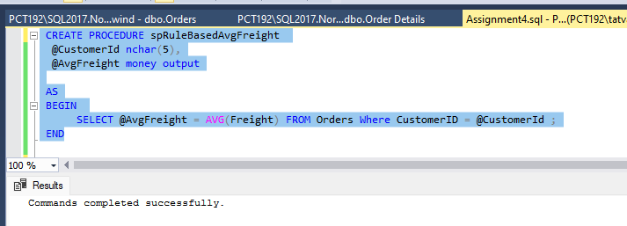
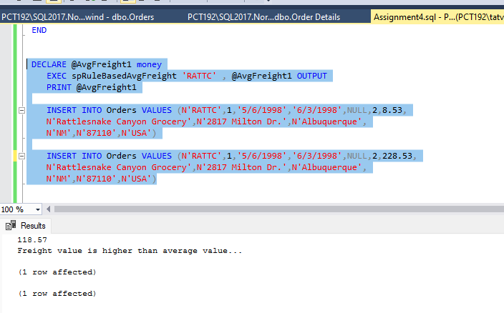

QuerySol 2:

CREATE PROC spEmployeeSalesByCountry
AS
BEGIN
Select e.EmployeeID, e.FirstName, e.LastName, e.Country, SUM( p.OrderSum ) as [Employee Sales]
from Employees e
Left join (Select o.OrderID, o.EmployeeID, od.OrderSum from Orders o
Left join (Select OrderId, (SUM(CONVERT(money,( UnitPrice * Quantity * (1-Discount)/100))*100)) as [OrderSum] FROM [Order Details] GROUP BY OrderID) od
on o.OrderID = od.OrderID) p
on e.EmployeeID = p.EmployeeID
Group by e.EmployeeID, e.FirstName, e.LastName, e.Country
END

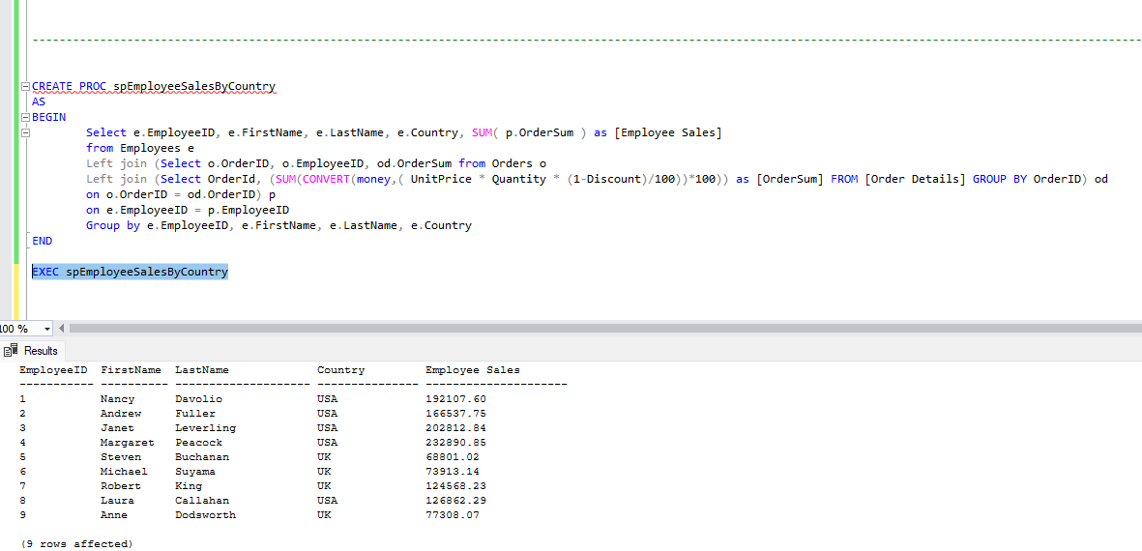

QuerySol 3:

CREATE PROC spEmployeeSalesByYear
AS
BEGIN
Select e.EmployeeID, e.FirstName, e.LastName, p.Salesyear, SUM( p.OrderSum ) as [Employee Sales]
from Employees e
Left join (Select o.OrderID, o.EmployeeID,YEAR(o.OrderDate) as [Salesyear], od.OrderSum from Orders o
Left join (Select OrderId, (SUM(CONVERT(money,( UnitPrice * Quantity * (1-Discount)/100))*100)) as [OrderSum] FROM [Order Details] GROUP BY OrderID) od
on o.OrderID = od.OrderID) p
on e.EmployeeID = p.EmployeeID
Group by e.EmployeeID, e.FirstName, e.LastName,p.Salesyear
END
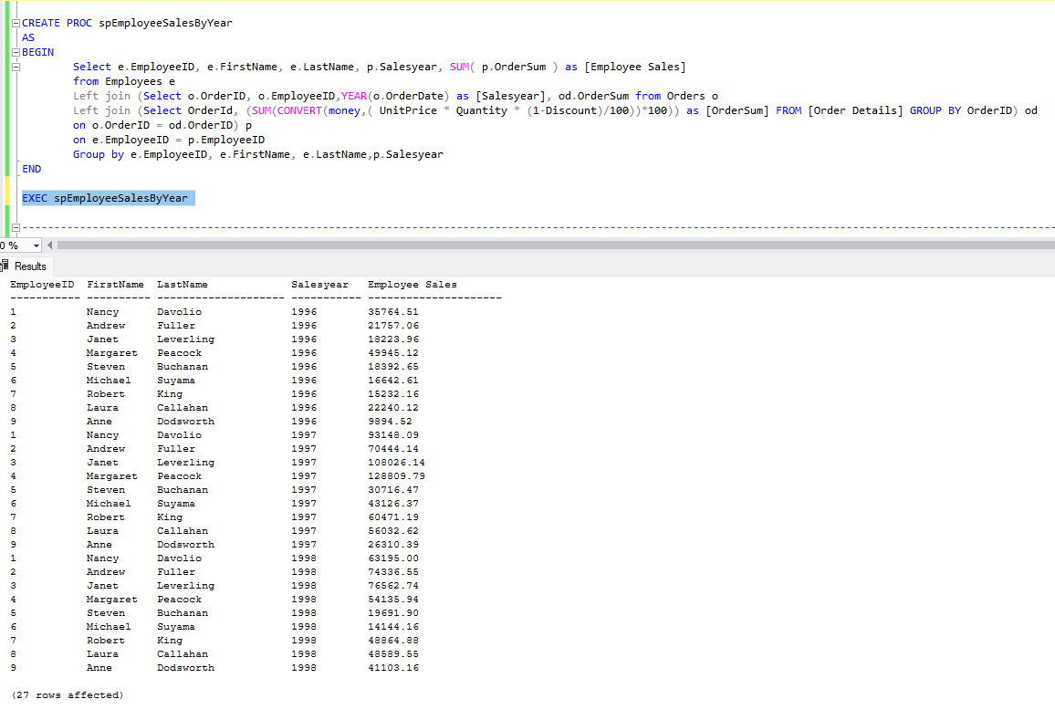

QuerySol 4:

CREATE PROC spSalesByCategory
AS
BEGIN
SELECT c.CategoryID, c.CategoryName, ct.[Total sales] FROM Categories c
inner join (select p.CategoryID,SUM(s.OrderSum) as [Total sales] from Products p
left join (Select ProductID, (SUM(CONVERT(money,( UnitPrice * Quantity * (1-Discount)/100))*100)) as [OrderSum] FROM [Order Details] GROUP BY ProductID) s
on p.ProductID = s.ProductID
Group by p.CategoryID) ct
on c.CategoryID = ct.CategoryID
END

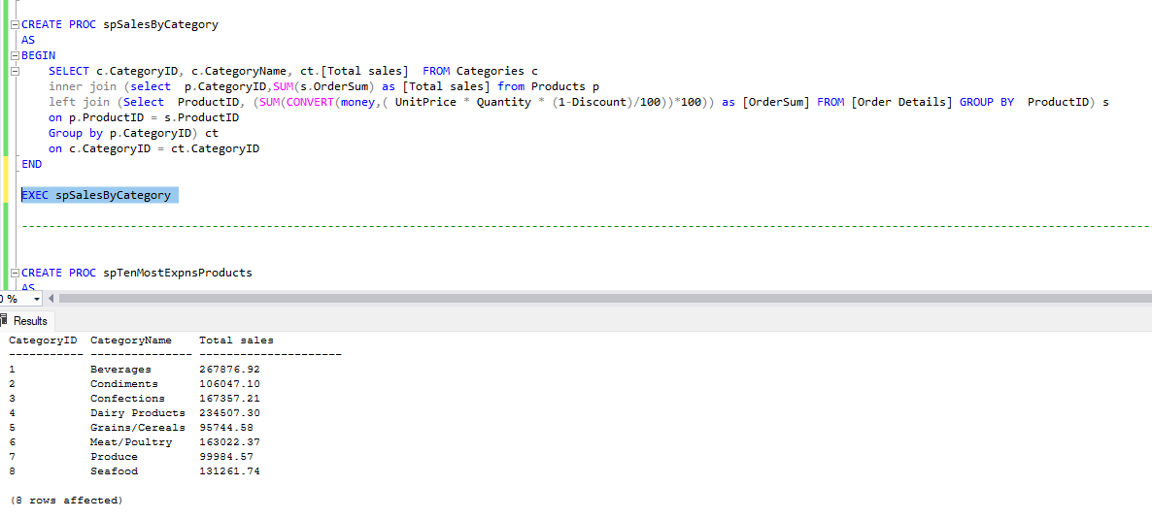

QuerySol 5:

CREATE PROC spTenMostExpnsProducts
AS
BEGIN
SELECT TOP(10) * FROM Products ORDER BY UnitPrice DESC
END

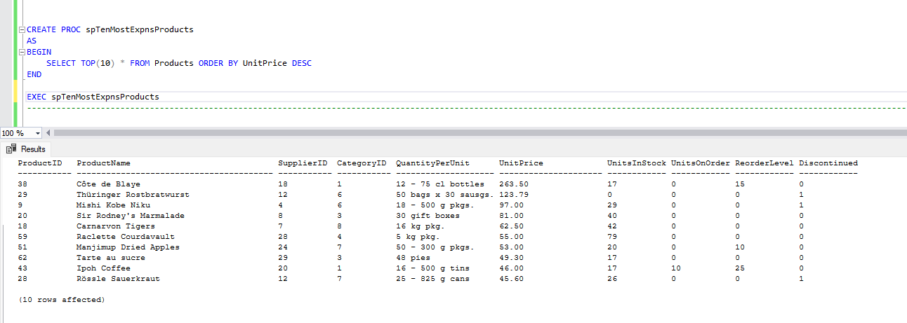

QuerySol 6:

CREATE PROC spInsertOrderDetails
@OrderId int,
@ProductId int,
@UnitPrice money,
@Quantity smallint,
@Discount real

AS
BEGIN
INSERT INTO [Order Details] VALUES (@OrderId, @ProductId,@UnitPrice, @Quantity, @Discount)
END

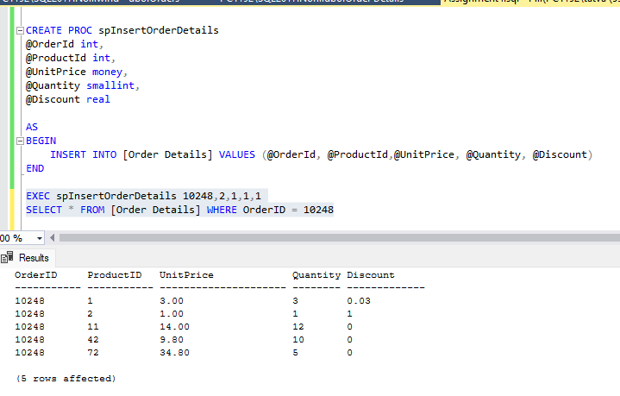

QuerySol 7:

CREATE PROC spUpdateOrderDetails
@OrderId int,
@ProductId int,
@NewUnitPrice money,
@NewQuantity smallint,
@NewDiscount real
AS
BEGIN
UPDATE [Order Details]
SET UnitPrice = @NewUnitPrice, Quantity = @NewQuantity, Discount = @NewDiscount
WHERE OrderID = @OrderId AND ProductID = @ProductId
END

